CYPRESS Installation Guide

Installation Components:

1. Code Editor – VS Code (Microsoft ) – Download from <https://code.visualstudio.com/download>

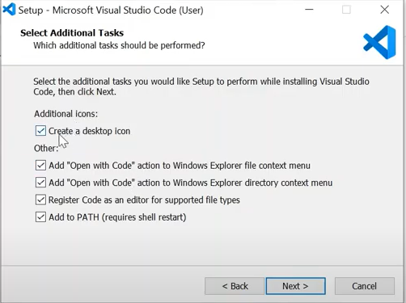

Confirmation of Installation

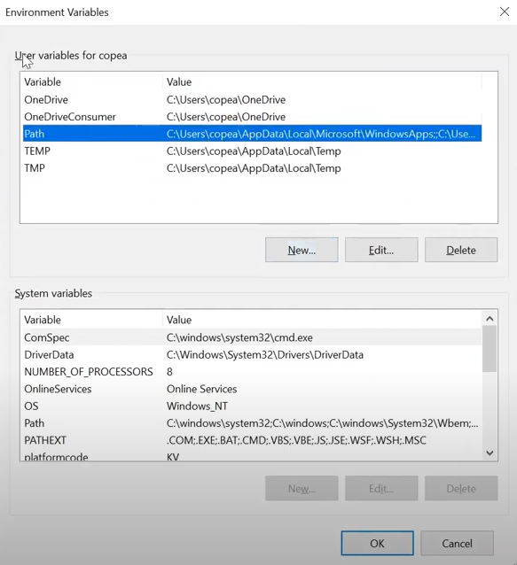

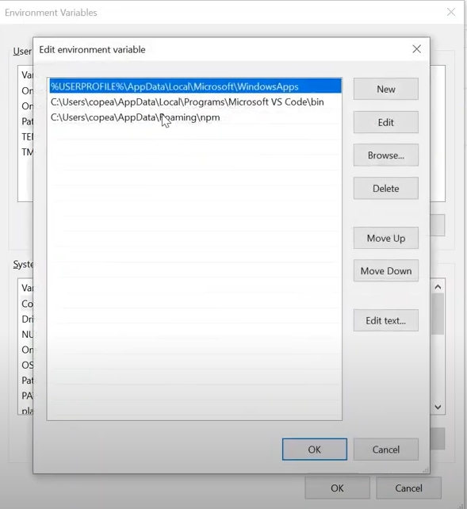

CMD prompt > code .> opens vs code

1. Node.Js- Node Js and NPM – download from <https://nodejs.org/en/download/>

Confirmation of installation:

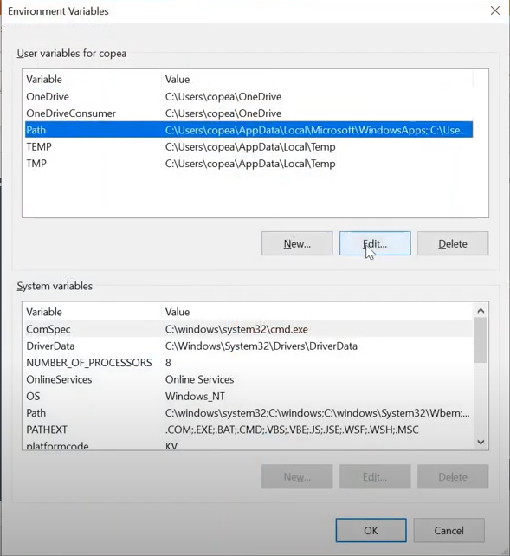

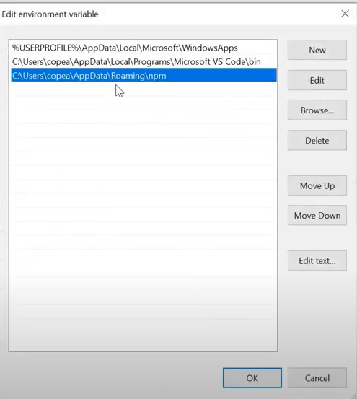

CMD Prompt: node –version> displays the version

CMD Prompt: npm –version > displays the version

1. Cypress installation : Create a folder in Documents> Workspace> Cypress > Project Name

Example: C:\Users\smanjeshwar\Documents\Workspace\Cypress\cypress_e2e_automation

1. Click on folder address bar > type cmd
2. In the command prompt type code . And hit enter
3. Type npm init and hit enter , skip package name and version ( this is the process to create package.json which is equivalent to pom.xml in selenium)
4. Enter a description of your choice and enter , skip entry point , test command and git repository fields
5. Keywords, type keywords of your choice and hit enter
6. Author, type name of your choice and hit enter
7. Licence, hit enter
8. Is this OK ? (yes) type yes and hit enter
9. Refresh the project name folder in vs code using the refresh icon and verify if package.json file is displayed
10. Go back to cmd and your project folder and type install cypress ( might take some time )
11. Verify vs code app for folders like cypress , node_modules , bin (this folder will have executable files)
12. Add extension for cypress like code runner, npm intellisense and path intellisense as follows :

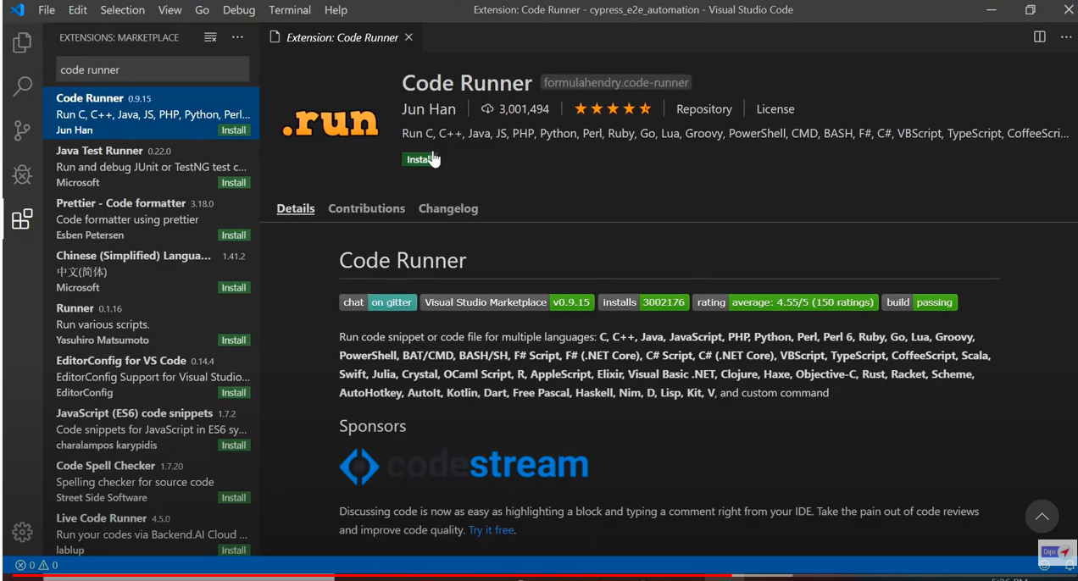

Npm intellisense helps in providing existing commands

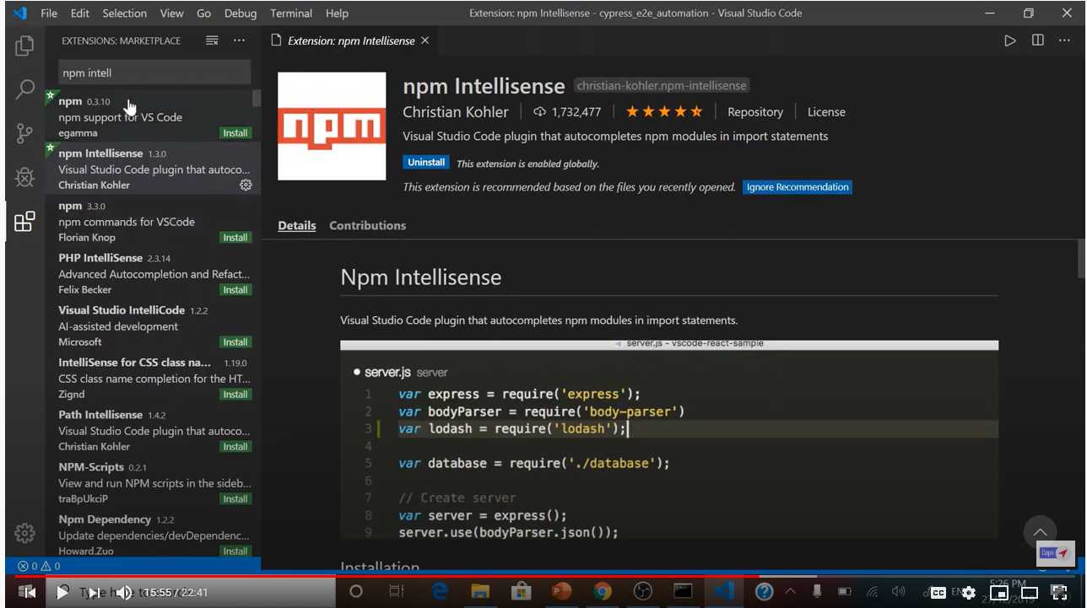

Path intellisense : Deals with file system suggest directories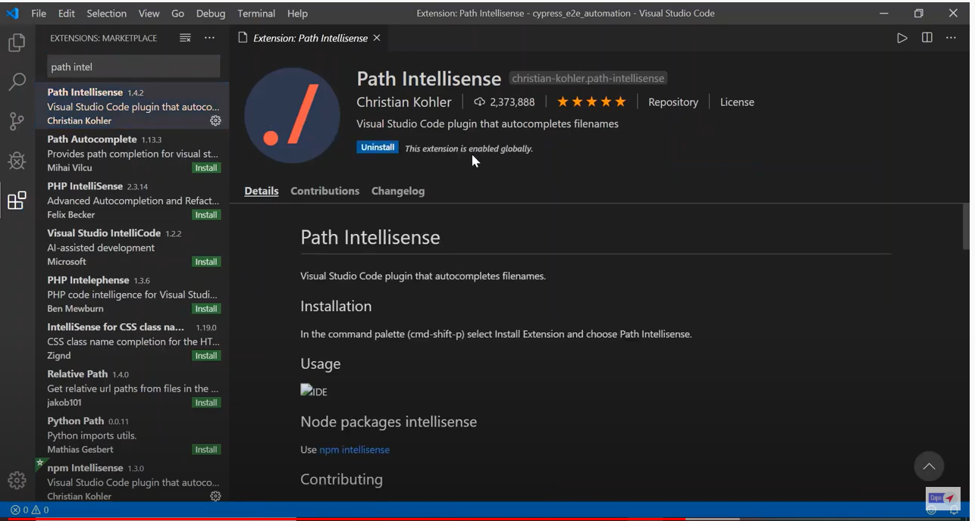

Running trail tests:

Navigate to your project folder (Example: C:\Users\smanjeshwar\Documents\Workspace\Cypress\cypress_e2e_automation

) in cmd prompt and type cd node_modules\.bin> cypress –help this will give options on various ways to run tests

One of the option is

Navigate to package.json in vs code and type yellow highlighted text and save as follows:

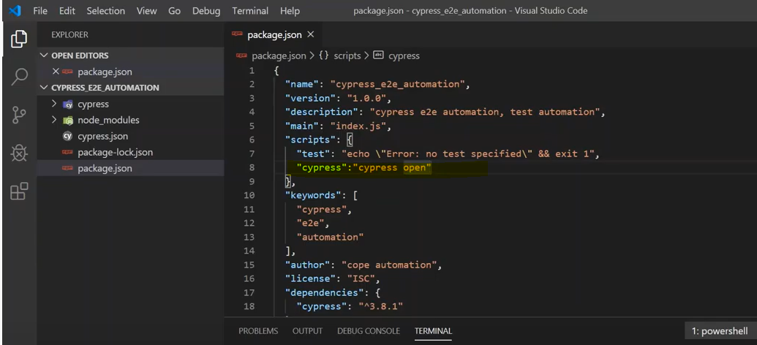

Navigate to Terminal in vs code and type npm run cypress after your project path and hit enter > This will open the GUI for cypress .

Select any .js folder and click on it, which will run some default tests that are in cypress folder